Task 1 : Salary Transformation System

Program:
import java.util.*;
import java.util.stream.*; public class Main {
public static void main(String[] args) { Scanner sc = new Scanner(System.in); int N = sc.nextInt();
int[] salaries = new int[N]; for (int i = 0; i < N; i++) {
salaries[i] = sc.nextInt();
}
int[] updatedSalaries = Arrays.stream(salaries)
.map(salary -> salary + (salary * 10 / 100))
.toArray();

for (int i = 0; i < updatedSalaries.length; i++) { System.out.print(updatedSalaries[i]);

if (i < updatedSalaries.length - 1) { System.out.print(" ");
}
}
sc.close();
}
}

Output :
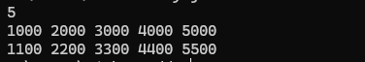

Task 2 : Real-Time Stream Analytics Engine

Program:
import java.util.*;
import java.util.stream.*;

class Reading { String sensorId;
double temperature;

Reading(String sensorId, double temperature) { this.sensorId = sensorId;
this.temperature = temperature;
}
}
public class Main {
public static void main(String[] args) { Scanner sc = new Scanner(System.in);

int N = sc.nextInt();

List<Reading> readings = new ArrayList<>();

for (int i = 0; i < N; i++) { String sensorId = sc.next();
double temperature = sc.nextDouble();
readings.add(new Reading(sensorId, temperature));
}

Map<String, Double> avgTemps =

readings.stream()
.filter(r -> r.temperature > 50)
.collect(Collectors.groupingBy( r -> r.sensorId,
Collectors.averagingDouble(r -> r.temperature)
));

avgTemps.entrySet()
.stream()
.sorted((e1, e2) ->
Double.compare(e2.getValue(), e1.getValue()))
.forEach(e ->
System.out.println(e.getKey() + " " + e.getValue()));

sc.close();
}
}

Output :

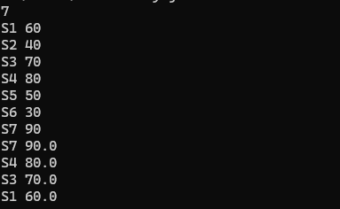

Task 3 : Maximum Profit Analyzer

Program:
import java.util.*; public class Main {
public static void main(String[] args) { Scanner sc = new Scanner(System.in); int N = sc.nextInt();
int[] arr = new int[N]; for (int i = 0; i < N; i++) {
arr[i] = sc.nextInt();
}

int currentMax = arr[0]; int maxSoFar = arr[0]; for (int i = 1; i < N; i++) {
currentMax = Math.max(arr[i], currentMax + arr[i]); maxSoFar = Math.max(maxSoFar, currentMax);
} System.out.println(maxSoFar); sc.close();
}
}

Output :

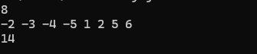

Task 4 : Intelligent DNA Pattern Search

Program:
import java.util.*;

public class Main {

static void computeLPS(String pattern, int[] lps) { int len = 0;
int i = 1;

while (i < pattern.length()) {
if (pattern.charAt(i) == pattern.charAt(len)) { len++;
lps[i] = len; i++;
} else {
if (len != 0) {
len = lps[len - 1];
} else {
lps[i] = 0; i++;
}
}
}
}

static void KMPSearch(String text, String pattern) { int n = text.length();
int m = pattern.length();

int[] lps = new int[m]; computeLPS(pattern, lps);

int i = 0; int j = 0;

while (i < n) {
if (pattern.charAt(j) == text.charAt(i)) { i++;
j++;
}

if (j == m) {
System.out.print((i - j) + " "); j = lps[j - 1];
} else if (i < n CC pattern.charAt(j) != text.charAt(i)) { if (j != 0) {
j = lps[j - 1];
} else { i++;
}
}
}

}

public static void main(String[] args) { Scanner sc = new Scanner(System.in);

String text = sc.nextLine(); String pattern = sc.nextLine();
KMPSearch(text, pattern); sc.close();
}
}

Output :
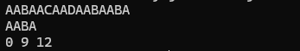

Task 5 : Banking Transaction System

Program:
import java.util.*;

class BankAccount { private int balance = 0;

public void deposit(int amount) { balance += amount;
}

public void withdraw(int amount) { balance -= amount;
}

public int getBalance() { return balance;
}
}

public class Main {
public static void main(String[] args) { Scanner sc = new Scanner(System.in);

int N = sc.nextInt(); sc.nextLine();

BankAccount account = new BankAccount();

for (int i = 0; i < N; i++) {
String operation = sc.next(); int amount = sc.nextInt();

if (operation.equalsIgnoreCase("Deposit")) { account.deposit(amount);
} else if (operation.equalsIgnoreCase("Withdraw")) { account.withdraw(amount);
}
}

System.out.println(account.getBalance());

sc.close();
}
}

Output :
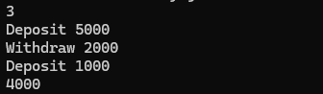

Task 6 : Ride Sharing Platform Simulator

Program:
import java.util.*;
abstract class Vehicle {
abstract int calculateFare(int distance);
}
class Bike extends Vehicle { @Override

int calculateFare(int distance) { return distance * 5;
}
}
class Auto extends Vehicle { @Override
int calculateFare(int distance) { return distance * 12;
}
}
class Cab extends Vehicle { @Override
int calculateFare(int distance) { return distance * 12;
}
}
public class Main {
public static void main(String[] args) { Scanner sc = new Scanner(System.in);

int N = sc.nextInt();

for (int i = 0; i < N; i++) { try {
String rideType = sc.next(); int distance = sc.nextInt(); if (distance < 0) {
throw new IllegalArgumentException("Invalid Distance");

}
Vehicle vehicle; switch (rideType) {
case "Bike":
vehicle = new Bike(); break;
case "Auto":
vehicle = new Auto(); break;
case "Cab":
vehicle = new Cab(); break;
default:
throw new IllegalArgumentException("Invalid Ride Type");
}
System.out.println(vehicle.calculateFare(distance));
} catch (Exception e) {
System.out.println("Invalid Booking");
}
}

sc.close();
}
}

Output :
